Experiment 16
Program:
import cv2
import numpy as np
# Read the image
img = cv2.imread("image.jpg")
# Convert to grayscale
gray = cv2.cvtColor(img, cv2.COLOR_BGR2GRAY)
# Apply Sobel filter in X direction
sobelx = cv2.Sobel(gray, cv2.CV_64F, 1, 0, ksize=5)
# Apply Sobel filter in Y direction
sobely = cv2.Sobel(gray, cv2.CV_64F, 0, 1, ksize=5)
# Display the images
cv2.imshow("Original Image", img)
cv2.imshow("Sobel X", sobelx)
cv2.imshow("Sobel Y", sobely)
cv2.waitKey(0)
cv2.destroyAllWindows()
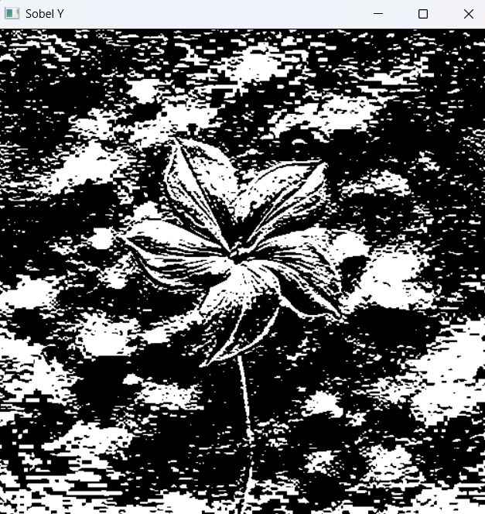
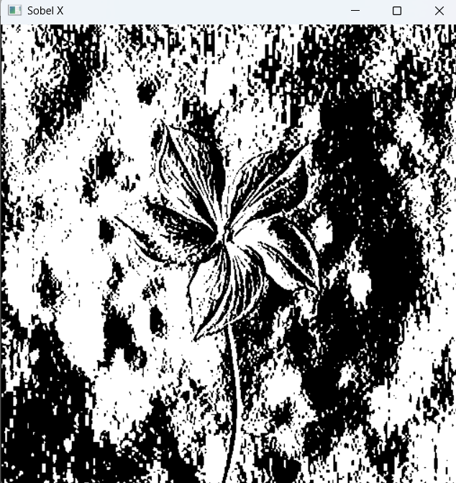
Output:

